**Table 3.1**

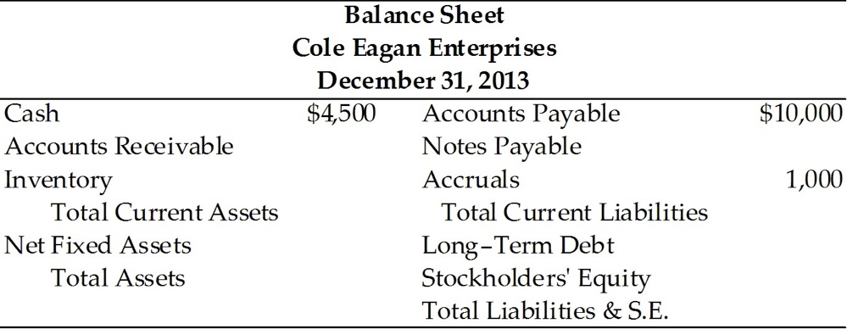

Information (2013 values)

1. Sales totaled $110,000

2. The gross profit margin was 25 percent.

3. Inventory turnover was 3.0.

4. There are 360 days in the year.

5. The average collection period was 65 days.

6. The current ratio was 2.40.

7. The total asset turnover was 1.13.

8. The debt ratio was 53.8 percent.

14) Inventory for CEE in 2013 was ________. (See Table 3.1)

A) $36,667

B) $32,448

C) $27,500

D) $ 9,167

Answer: C

Diff: 3

Topic: Debt Ratios

Learning Obj.: LG 4

Learning Outcome: F-02

Question Status: Revised

AACSB Tag: Analytic Skills

15) Notes payable for CEE in 2013 was ________. (See Table 3.1)

A) $113,466

B) $ 52,372

C) $ 41,372

D) $ 10,609

Answer: D

Diff: 3

Topic: Debt Ratios

Learning Obj.: LG 4

Learning Outcome: F-02

Question Status: Revised

AACSB Tag: Analytic Skills

16) Accounts receivable for CEE in 2013 was ________. (See Table 3.1)

A) $14,056

B) $19,861

C) $14,895

D) $18,333

Answer: B

Diff: 3

Topic: Debt Ratios

Learning Obj.: LG 4

Learning Outcome: F-02

Question Status: Revised

AACSB Tag: Analytic Skills

17) Net fixed assets for CEE in 2013 were ________. (See Table 3.1)

A) $45,484

B) $48,975

C) $54,511

D) $69,341

Answer: A

Diff: 3

Topic: Debt Ratios

Learning Obj.: LG 4

Learning Outcome: F-02

Question Status: Revised

AACSB Tag: Analytic Skills

18) Total assets for CEE in 2013 were ________. (See Table 3.1)

A) $ 45,895

B) $124,300

C) $ 58,603

D) $ 97,345

Answer: D

Diff: 3

Topic: Debt Ratios

Learning Obj.: LG 4

Learning Outcome: F-02

Question Status: Revised

AACSB Tag: Analytic Skills

19) Long-term debt for CEE in 2013 was ________. (See Table 3.1)

A) $30,763

B) $52,372

C) $10,608

D) $41,372

Answer: A

Diff: 3

Topic: Debt Ratios

Learning Obj.: LG 4

Learning Outcome: F-02

Question Status: Revised

AACSB Tag: Analytic Skills